5.4 Conics Summary Worksheet

- Find the vertex of the graph .

Let’s first get our quadratic into vertex form by completing the square:
So
Vertex:

- Consider the equation of a conic: .

  - Does this equation represent a parabola, ellipse, circle, or hyperbola?

So we see that this is the equation of a circle.

  - Carefully sketch a graph of the above equation.

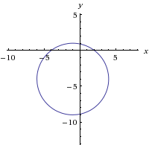

- Consider the equation of a conic:
  - Does this equation represent a parabola, ellipse, circle, or hyperbola?

So we see that this is the equation of an ellipse.

  - Carefully sketch a graph of the above equation.
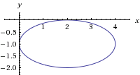

- Consider the equation of a conic:
  - Does this equation represent a parabola, ellipse, circle, or hyperbola?

So we see that this is the equation of a hyperbola.

  - Carefully sketch a graph of the above equation.

Our fundamental rectangle has corners of
Our asymptotes are given by the equations:

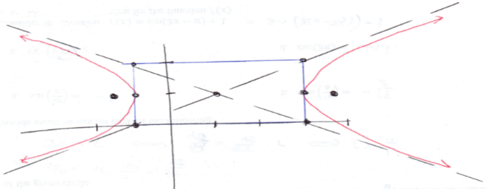

- Consider the equation of a conic:
  - Does this equation represent a parabola, ellipse, circle, or hyperbola?

So we see that this is the equation of a circle.

  - Carefully sketch a graph of the above equation.

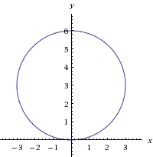

- Consider the equation:
  - Does this equation represent a parabola, ellipse, or hyperbola?

We can see that there is no $x^{2}$ term in this equation, so the equation must represent a parabola that opens left or right.

So we see that this is the equation of a parabola.
From this equation we can also identify the following values:

  - Carefully sketch a graph of the above equation.

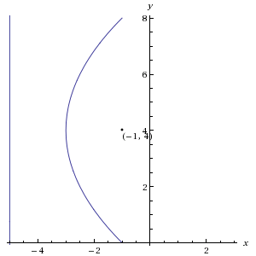

- Consider the conic given by the equation: .
  - Does this equation represent a parabola, ellipse, or hyperbola?

So we see that this is the equation of a hyperbola.

  - Carefully sketch a graph of the above equation.
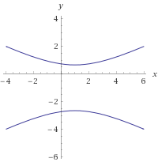
Our fundamental rectangle has corners of
Our asymptotes are given by the equations:

